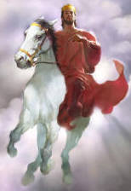
Visions of the Rapture, Tribulation, the Holy City,
& the Thrones of GOD and satan.
The testimony of an 8 year old girl who encountered Jesus Christ.
(Jannet Balderas Canela)
Originally Translated from Spanish Audio, Illustrations were added and not part of the original testimony. This testimony has been verified and confirmed by an independent & trusted prophet. (www.DivineRevelations.info)
Dear brothers, may the Lord bless all of you in this hour. Let’s read from the Bible in 2 Corinthians 12:1-4, the Holy Word of God. In the name of the Father, the Son, and the Holy Ghost "I must go on boasting. Although there is nothing to be gained, I will go on to visions and revelations from the Lord. I know a man in Christ who fourteen years ago was caught up to the third heaven. Whether it was in the body or out of the body I do not know—God knows. And I know that this man—whether in the body or apart from the body I do not know, but God knows—was caught up to paradise. He heard inexpressible things, things that man is not permitted to tell."
I will relate to you an experience that I had with the Lord on September 5th, 1999. We were in the church and the power of God was there filling our lives. I fell to the floor and felt the Lord's presence in me. I felt that the Lord was dealing with me, and He began to show me visions.

In one vision, I saw two roads, one was very wide, with many people walking on it, but they were walking towards their destruction. The other road was very narrow, I saw there were many people walking down this road, praising and giving honor to the Lord.
Then the Lord showed me another vision where an angel was fighting with a dragon. The dragon threw fire and demons to this Earth.

After that I saw another vision of a very bright shining clock. It was made of gold. The time shown was twelve o'clock. But I saw a hand make the clock go back to eleven o'clock. The Lord told me, "Look, My servant, I take the time back because My people are not prepared as I want them to be, I am taking the time back, because My people don't praise Me as I want, that is why, because of My great mercy I am giving a last chance, so that everyone that comes to My feet shall receive eternal life"
Then the Lord showed me another vision, while I was still lying on the floor. I saw a man riding a horse towards me. He extended His hands, and got closer to where I was laying on the floor. Then I felt the Lord take me into His arms. I felt Him take my spirit out of my body and into His Arms. We then began to ride, we rode upwards and stopped in a place not too high or low. He said to me, "Look My servant, I told you that I was going to bring you with Me, and that is what I am doing now, because what I say with My mouth I fulfill. What I say, I do. That is why I have brought you here My servant. But first I will show you My wounds, so you will take into account and never forget what I have done for all of you."
We arrive to the Throne of God and the Lord showed me the place where the nails were put and where His side was pierced. He also showed me how He was whipped. I saw all the marks and stripes He took for all of us. He said, "Look My servant, many of you do not take into account all I have done for you, many of you forget that I died for you on the Calvary cross, and I feel pain My servant. I feel pain when My people deny me, like opening that wound again, and it hurts Me. It is like they are crucifying Me again on the cross." I saw how the Lord was crying, because He feels pain when we let Him down.

-HEAVEN-
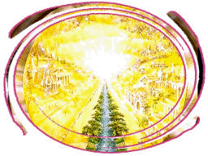
He said, "Servant I will show you many things, I will show you the streets of gold and the crystal sea, so you can go and tell My people the grandeurs that I have for them."
We soon arrived to a place with beautiful streets, so beautiful. I have never seen or touched such things on Earth. The streets were shining! The Lord said, "My servant, touch this street of gold, because you and My people will live here, because here My people will ride very soon." I saw the reflection of the Lord and me riding together.
After that we arrived at the crystal sea, it was so beautiful. While I was riding with the Lord through that precious sea He told me, "My servant, all this is not Mine, all this is for My people. All that you can touch I have prepared it with so much love for My people." Then He said, "Servant come here, because I will show you other things."
We then arrived in a beautiful place where I could see the glory of God, and feel His Power. It was a big beautiful place. I saw many tables, so I asked the Lord, "Lord what are all these tables are for?" He said, "Servant, remember the Wedding of the Lamb, remember that on these tables we will celebrate the Wedding of the Lamb." I saw countless numbers of tables, and I could not see the end of them. There were angels at each table, so I asked the Lord, "Lord, why is there an angel at each table and at each chair?" The Lord said, "My servant, these angels are decorating the tables, these angels are getting ready each table because I am already preparing everything."
Dear brothers, those tables were so shiny; all of them were made of gold. The tables were very nicely decorated. I saw how each angel was putting on the fork, the knife, the spoon, the glasses, the dishes, all made of gold, so beautiful. The Lord told me, "Servant, tell My people to get ready because very soon I will take them with Me so they can come here and enjoy with Me in the Wedding of the Lamb."
It was so beautiful; the presence of the Lord could be felt there, such glory and majesty! The Lord said, "Servant, come here because I will show you other things." We arrive at a place with many beautiful doors, so many beautiful doors. I said, "Lord what's behind those doors?" He said, "Behind these doors are My disciples, behind these doors are My apostles, behind these doors are all those who once walked over the Earth praising and glorifying My Name."

-MARY-
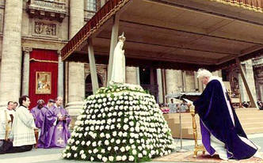
We began to ride again and arrive at a door that was half-opened, and the Lord said, "Servant come here, come here because behind this door is Mary. Get close and hear what she is saying, so you can go and tell My people, so you can tell the people how Mary is suffering." I got closer and saw a young lady, such a beautiful young lady, so beautiful, her face was so pretty. She was looking through a very tiny window. She was kneeling down and looking to the face of the Earth, crying with tremendous pain.
She said, "Why are you worshiping me? Why, if I do not have any power! Why are you worshiping me? I do not do anything! Do not worship me! Do not bow before me! For I cannot save you! The only one that can save, the only one that can redeem you is Jesus, who died for all mankind! Many people say that I have power, that I can perform miracles, but that is a lie! I do not do anything! Almighty God was satisfied with me and He used my womb so that Jesus could be born and save everyone, but I don't have any power. I cannot do anything! Do not bow before me! Do not worship me! For I am not worthy of worship. The only one that is worthy, the only one that you bow before and adore is Jesus! He is the only one that heals and saves!"
I could see how that young lady was in such tremendous pain, full of anguish and crying. She said, "No! No! Do not worship me! Why do you bow before me? I don't do anything!" You see dear brothers, it was a tremendous thing to look at this young lady, how she was crying with such pain and sadness.

-ROBES AND CROWNS-
The Lord told me, "Servant come here, because I will continue showing you things." We arrive at a very beautiful place where I could feel the glory of God. I saw lines and lines of white robes, so very white and beautiful! I touched them and the Lord said, "Servant, touch these robes, because these robes are for all of you."
I saw many lines and touched the fine clothe. It was so shining and white, like nothing I have touched on Earth. The Lord said, "Servant, these robes are for all of you." There were tears running down the Lord's cheeks. The Lord said, "Servant, many of these white robes will remain here, waiting for someone to take them. Many of these robes will remain here, waiting for a body." "Why Lord?" I asked. "Because many do not worship Me as I want, many do not pay any attention to all the things I do for all of you. Servant, many of these white robes will remain here, waiting for a body, because in My kingdom I do not receive anything dirty. In My kingdom I only allow holy things, because it is written in My Word, be holy, because I am holy." (1 Peter 1:16)
I looked and saw many robes; each one had a name written in gold. I touched the robes that were smaller and of different sizes, and I said, "Lord, these small ones, who are going to wear them?" The Lord replied, "Servant, remember My little children, remember that I have for everyone, I am not a respecter of persons, these little robes are for My little children that praise My Name, they are for My children who like to go to My House and glorify My Name, therefore I have prepared big things for them. I have for everyone that looks for Me, I have for all those that come to My feet, I give them Eternal Life."
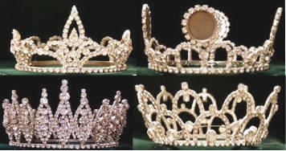
We began to ride again and soon arrived at a huge place with many crowns. There were luxurious crowns, shining crowns, so I said, "Oh Lord! Those crowns, they are so beautiful. Who are these crowns for?" The Lord said, "Servant, these crowns you are touching, are for those that praise My name, for those that truly glorify My Name the way I want."
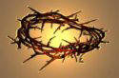
The Lord showed me other crowns, but I noticed that they were just a frame. Then the Lord said, "Servant look in this direction." And I began to see other crowns, but these crowns were made of thorns, so I said, "Lord, don't let a crown of thorns or a simple frame be for me!" The Lord told me, "Servant, in this place there are three types of crowns: the luxurious and shinny crowns that you can see and touch are for those that truly praise My Name, for all those that truly and with all their hearts glorify and praise My Name. They are for those that work in My vineyard, for those that enjoy to be in My house, for those that like to make an effort and take pains to be pleasant for My Word. The crowns that are just a frame, that you can see and touch are for those that are just playing with My word, it is for those that do not like to be in My house, it is for those that do not like to fast, nor to persevere, neither glorify My Name, they are for those that just praise Me with their lips but not with their hearts as I want. Why My servant? Because nobody can deceive Me, there is no place to hide from Me. Servant, those crowns made of thorns that you can touch and see, are for those that make fun of My Word, they are for those that criticize My Word, they are for all those who I am knocking at their hearts but they do not want to accept My Word, for all those that criticize My Word."

-VISION OF THE RAPTURE-
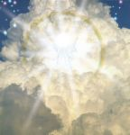
After that the Lord said, "Servant I will show you the rapture, I will show you how My coming will be." So I said, "Lord I have already seen many things, why are you going to show me more?" Then we arrive at the Throne of God, and I saw thousands and thousands of angels gathered together there. Then we started to go down, and the Lord and I stopped in a very white beautiful cloud. The Lord gave orders to the angels to come and receive the church, and the Lord told me, "Servant watch carefully, because this is the way it will be when I come back, this will be My coming."
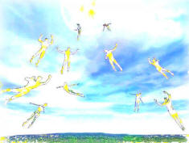
I saw people raised from the four corners of the Earth, praising the Name of the Lord. All those people were cover with the power of God. They were dressed in white robes rising up and up. They began to sing a very beautiful song, "Holy, Holy, Holy are thee oh Lord! Thank You Father! For you have raised us! Thank you Lord, for you have raised us!"
I saw many different people, tall, short, dark, white. All the people, and all those angels went up to the cloud where the Lord and I were. All the people and angels were full of thanksgiving to the Lord, and we all said, "Holy! Holy! Holy are thee oh Lord!" It was such a tremendous thing, I saw so many people that I thought I knew them. They all were cover with the glory of God.

-VISION OF THE TRIBULATION-
After that we arrived at the Throne of God, and the Lord said, "Servant, come here." We went out of the Throne room and arrived at a place with a very tiny window. The Lord said, "Servant, now look down." I saw terrible desolation, such tremendous desolation; the whole Earth was desolate and full of pain. The Lord said, "Look servant, this is what is going to be after I have taken My people from the Earth, this will be after My coming, this will be when My church is here with Me." I saw such tremendous desolation.
I saw people that were celebrating one moment, but then, I saw a father looking for his son, a mother looking for her daughters, but they couldn't find them, because Almighty God had taken them. Relatives were looking for other relatives but they could not find them. People were looking for their neighbors but couldn't find them, because the Lord had taken them up with Him.
Something terrible what was happening over all the Earth. I saw a pastor running from one place to another, and I asked the Lord, "Lord, why does that man run from one place to another?" The Lord replied, "Servant, this man was a pastor, but because he thought that I was going to delay, he was left behind. He did not think that I was going to come now, he thought that it was going to take a long time before I would come back, and that is why he was left behind." The pastor was running all over, saying "Lord, why was I left behind? If I am a pastor, if I have a position in the church, and the church is gone, I am left behind? Why have I been left behind?" The Lord said, "Servant, I can't do anything now, he thought My coming was going to delay, well, he was left behind."
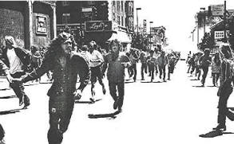
I saw how that man was persecuted. He said, "The only thing I want is to be taken with Christ! The only thing that I want is to be with the Lord because I do not want to be here and suffer in the great tribulation!" He kept running from place to place and asking himself, "Why was I left behind? Take me with You Lord! I don't want to be here and suffer!" The Lord said, "Servant, there is nothing I can do now, for a long time I talked with him and told him that I was going to come very soon, but he didn't believe me, well, now he is left behind."
I saw many other people running all over. So many people were running, desperate trying to find peace but they could not find it. They were shouting, "We want the Word of life! We are thirsty of the Word of God!" But it was already too late, because the Lord had taken the church with Him.
I saw so many young girls and boys running through the bushes, running through the mountains trying to find peace. They wanted peace but they could not find it. The Lord told me why, "Servant I have already taken My church, and now satan is the one in control." Satan was already ruling over the Earth and there was torment over all the Earth! People were running from place to place. People wanted to eat each other alive, and pull out each other's hair. They blamed each other and hurt each other, because they wanted to find peace, but they couldn't find it! It wasn't possible because the Lord had already taken His church.
Such a terrible time on Earth, I saw such horrifying things. So many people were hurting each other, saying, "We want love! We want peace!" But it was too late! The Lord told me, "Look My servant, I talked to them, I spend time knocking at the hearts of these people, but they did not want to look for Me. Well, now they are left behind, and there is nothing I can do for them now. Why, because I have already taken My church with Me. While all My people are with Me in heaven enjoying the marriage of the Lamb, all these people here will suffer great pain, and there will be weeping and gnashing of teeth. For they did not want to obey My Word, they preferred to make fun and criticize My Word."
-THE BOOK OF LIFE-
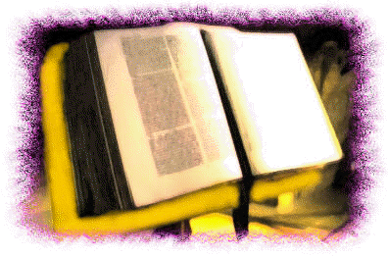
After that the Lord show me a big beautiful book. It was very shinny and made of gold. I said, "Lord that big book, what is it for?" He told me, "Servant in this book are the names of those that praise Me, and the names of those that have repented and have looked for My ways. For this is the Book of Life. In this Book are written all those that gather together to praise and glorify My Name." The book was so big, and had letters written in gold. He said, "Look My servant, many of these names I haven’t erased because of My mercy, because many have turn their backs on Me. Many have turn their back on Me, but My mercy is so big that I haven’t erased them yet, for I do not want that anyone perish, but that everybody have eternal life." I began to touch the Book, and saw how so many names were written in it.

-HELL-
After that the Lord told me, "Servant, I will show you hell." So I said, "Lord, no, I won’t be able to bear it, with all that You have shown me already, I’ve had enough." And the Lord told me, "Servant I will show you hell, so you will go and tell the church and the people that there is a heaven but there is also a hell." We started to go down and down. We were still far from hell when I began to hear shouts and great groans. I said, "Lord take me out of here, because I won’t be able to face this!" The Lord replied, "Look My servant, do not be afraid because I am with you." We went down through some tunnels. There was a great darkness in that place, a darkness like I have never felt on Earth.
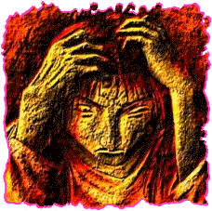
We walked by some walls and I heard so many souls shouting, shouts of pain and anguish. The Lord said, "Servant let's go forward." We arrive at a place where a person was shouting. I asked the Lord, "Lord, why have we stopped here?" He replied, "Look servant, look very carefully at this person, because this person was a relative of yours on Earth." And I said, "Lord who is? I can't recognize this person." The Lord said, "This person was your grandmother while on Earth, she was your relative, but she was very unbelieving, that is why she is here now."
She said, "Please give me water, take me out of here, because I cannot stand this pain anymore, I am thirsty." But I couldn’t do anything, the only thing I did was cry. I said, "Lord for your infinite mercy and your infinite goodness, take her out of here! Why is she here, if my parents told me she was in heaven?"
The Lord said, "Servant, the priest told your parents that she had gone to heaven, but that was a lie. That was a lie, because she used to bow before images, she adored images, and look how those images could not save her. Many times I knocked on her heart, so she would open it, and I would come inside, but instead she decided to make fun of My Word. She decided it was better to follow the world than honor My Name, and that is why she is here. She never wanted to accept My Word, she never wanted to repent, and the priest told them that she had flown to the heavens and that she was already in the heavenly mansions, but that was a lie. Look My servant, where she is." She was crying with such agony. She said, "Give me water! Take me out of here!" The Lord said, "Servant, I can’t do anything now, this soul doesn’t belong to Me anymore." We turned and walked away. She shouted to me, "No! Don’t leave me here! Give me water! Take me out of here!" He could not do anything.
We continued looking at so many people. Souls tried to grab the Lord's clothes, saying, "take us out of here!" But the Lord told them, "Get apart from Me, because you don’t belong to Me anymore, you belong to satan and his demons." It was such a terrible place, with so many souls, so many people.

-satan's throne-
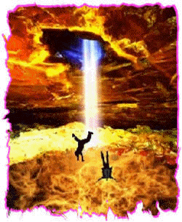
We continued ridding and arrived at a very terrible place, and the Lord said, "Look servant, I will show you the throne of satan." I told Him, "No Lord! I don’t want to see that throne!" He replied, "Servant don’t be afraid, for I am with you." Then we arrive at a terrible horrifying place, I saw a huge enormous chair with satan on. He had big nails, and he laughed and laughed, he could not stop laughing. I also saw demons everywhere. I saw demons of different sizes, I saw principalities, I saw strongholds, and many different demons. I saw how satan gave orders to his demons, orders to go up to the Earth and provoke all kinds of evil things.
I saw how those demons went up and provoked crashes, slaughters, fights, divorces and all kinds of evil things. Then they would come down and reported to him everything they did. And satan would laughed and laughed. satan gave prizes to the demons, and the demons began to celebrate him, and praise him and sing for him.
I saw how satan had so many plans to destroy Christians, big plans to destroy the servants of God. I saw huge churches and congregations that were full of modernism. The Lord said, "Look servant, these churches are possessed by satan, and they won’t be able to go up with Me."
The Lord showed me how demons provoked so many killing, and all those souls would then arrive in this damnation, a horrible place. I saw a furnace, and the Lord said, "Look servant, this is the lake of fire, and this is hell."
Every time the demons provoked slaughters, all the souls fell down to this place. The fire would consume them and they would melt. The souls cried with pain and horror, and the demons would come back to the throne of satan and tell him what they had done. satan would just laugh and laugh and give prizes to the demons. The demons would then sing and jump for him, and do all kinds of things to celebrate him. satan laughed with joy and pride because of all the souls that were arriving in hell. They kept falling second after second, and satan was so proud that he could stop laughing.
I also sensed many demonic feelings in that place, so many strongholds. I said, "Lord please take me out of here, I can't stand it anymore." The demons would poke and tormented the souls there. The souls would scream, "Leave us alone! Leave us in peace, we don’t want more torment, we want peace!" And the demons would laugh.

-THE HOLY CITY-
After that we left and the Lord said, "Look, servant I will show you the Holy City, so you can go and tell My people the grandeurs that I have for them." We went up and arrive at a beautiful place, where there were beautiful trees, pines so high. Everything was so beautiful there. I could feel such a sense peace.

In the door of that city was a beautiful rainbow. There were many angels on both sides of a road. We went through the door and the Lord said, "Servant, this is the Holy City." We walked until we arrived at a garden full of beautiful roses, like I've never seen on Earth.

I let go of the Lord's hand and I ran to the garden. I hugged the flowers, they were so fine and their smell was so delicious. I was going to cut a flower but the Lord said, "No servant, you cannot take anything yet. You will be able to take these flowers only when My people come here, when My church arrives to this place, then you will be able to take of these flowers." And I said, "Lord, I wanted to take just one flower to Earth and show it to all the churches." But the Lord said, "No, servant, because My people are not here yet." I saw many different type of beautiful flowers.
Then we rode through beautiful green grass. The Lord sat down on the grass, and with a beautiful smile He said, "Servant, all this that you touch and see I have prepared for My people."
We then rode to a place with a huge tree that was full of fruits. I said, "Lord, this tree? What does this tree mean? And all these fruits?" I was also going to pull off one of the fruits but the Lord told me again, "No, servant, you cannot take those fruits yet, because this tree is the tree of Life, and from this tree My people shall eat when they come up here. Meanwhile you cannot take anything until My people have arrived here." The tree had such beautiful fruits.
Then we continued ridding, and I saw so many beautiful butterflies and animals. The Lord said, "Servant all these things here are for My people. Tell My people that very soon, they are going to be here, ridding in this holy city."
We continued and arrived at another beautiful place, with many huge trees and pines. The Lord said, "Servant, all this is for My people. Servant, come here because I will show you wonders."
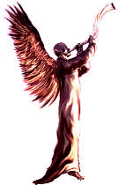
We arrive at a beautiful place that was full of angels. One angel was huge, and had a big trumpet to his mouth. I said, "Lord, that angel, what does that mean?" The Lord replied, "Look servant, this angel is waiting for a signal, this angel is waiting for an order that I give, so he can begin to sound the trumpet, and when this angel begins to play that trumpet, My people will be taken up, raised, and transformed. But be sure of one thing servant, this trumpet will be just heard by those that are watching! So go and tell My people to watch, tell to My people don’t sleep, because if you fall sleep, you won’t hear the trumpet, tell to My people to be watching, for those that are sleeping, I won’t be able to raise them up."
The angel was so big and beautiful, and behind him were many more angels that had smaller trumpets. Those trumpets were made of gold, and were very shiny. The Lord said, "Servant, tell My people to get ready, because I am about to give the order for the trumpet to sound."
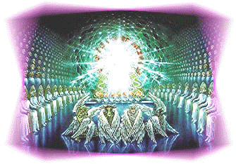
We began to ride again and the Lord said, "Look servant, I will show you the Throne of My Father. I haven’t showed it to you, but I will show you now, so you can go and tell My people that My Father is real, and that I am real." We all began to walk, the Lord, the angels and I. When we were still far from the Father's Throne, I felt that I could not take it anymore; I could not stand before such power and glory. As we got closer and closer, I felt like I was like a feather, I could hardly walk. If the angels were not holding me, I could not continue walking.
We arrived at the Throne of the Father, and I could feel such tremendous power from the Throne. Powerful lightning came from the Throne; it was so glorious and huge. Such power surrounded the Throne; it was glowing and made of gold. Someone was sitting on the Throne, but I could not see His face, I could not stand the power coming from the Throne. I could only see the Father from His waist down. But from His waist up, I couldn’t see because then I fell to the floor. I fell because I could not bear such power and glory.
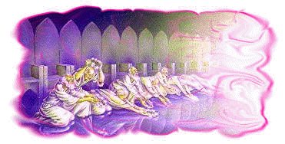
After that I saw 24 elders praising and glorifying the Name of the Lord. I saw huge archangels also glorifying the Name of the Lord. The 24 elders knelt down saying "Holy, Holy, Holy are thee oh Lord!" The angels never got tired of glorify and praising the Lord, and the elders never stopped glorifying the Name of the Lord. Tremendous fire came from the Throne, and there were so many beautiful things in that Throne.
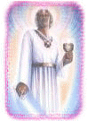
Then we left and came to a place where there was a huge angel. I said, "Lord who is that angel?" The Lord replied, "Look servant, this is the angel Gabriel, and look at this other angel, for this is Michael." They were so big and beautiful. The Lord said, "Servant, tell to My people that the angel Gabriel and the angel Michael really exist."
Afterwards the Lord said, "Servant, come here, because I will show you the whip." We arrive to another place where I saw the Lord take out a whip that had tree ends. He hit it against a very big chair, and said, "Servant this is for the disobedient, this whip is for those that do not want to obey My Word. Since they do not want to obey My Word, well, then I will whip them with this whip, because I punish those who I love." I saw how the Lord hit the chair with that whip, and I said, "Please Daddy, don’t hit me with that whip!" He replied, "Well servant, then obey me, because those who don’t obey Me I discipline." (Revelation 3:19 Those whom I love I rebuke and discipline. So be earnest, and repent.)
Then the Lord took me to a precious place, a tremendous place, where I saw more crowns of gold. But those crowns already had names written on them, and were full of pearls! The Lord said, "Look servant, this crown here is for My servant Yiye Avila, and this other one is of My servant Arturo García." The crowns were precious! On one crown was written "Aida Vadillo", another had "Miguel Duran", and another had "Armando Duran." "Lord now I can see and touch all the crowns of the servants." I also saw crowns for "Pablo Pintado", and "Nahum Zamudio."
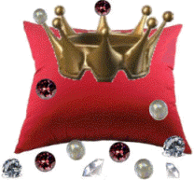
The Lord said, "Servant, here I allow you to see. This is to show you that the crowns of My servants who are working in My vineyard, I have them here. So you can see My servants that are preaching My word. I have big rewards for them." I saw thousands and thousands of crowns, all of them with names written on.
I touch another crown, but I saw this crown began to lose all the stones on it. "Lord! Don’t let this be my crown!" The Lord said, "Look servant, this is what it happens to those that don’t want to work in My vineyard anymore, to those that prefer to turn their backs to Me rather than praise Me. Look servant, these servants that don’t want to praise Me anymore, this is what happens to their crowns. The servants that don’t want to work in My vineyard anymore, this is what it happens to their crowns." (Revelations 3:11)
Then the Lord took me to another very beautiful place, and I saw a lot of people that were sleeping. They had on very white robes. I said, "Lord, who are all these people?" The Lord replied, "Look servant, all these people here are those that have died on Earth, and now they are here resting in paradise, and when I give the order for the trumpet to be sounded, the ones that are dead shall be raised first and then the ones that are on the Earth." There were so many people, and their garments were so white. (1 Thessalonians 4:16-17)
Nobody was talking to anyone else; they were just sleeping, in a very deep sleep. And the Lord told me, "Servant they are resting, but when the trumpet sounds, these will raise up first, and then those who remain on the Earth will be raised up together with them, to be with Me. And then we can celebrate the Wedding of the Lamb."
[The END]
by Jannet Balderas Canela

